# Apple/蘋果•手機版-Google Meet下載•安裝•進入會議 流程

[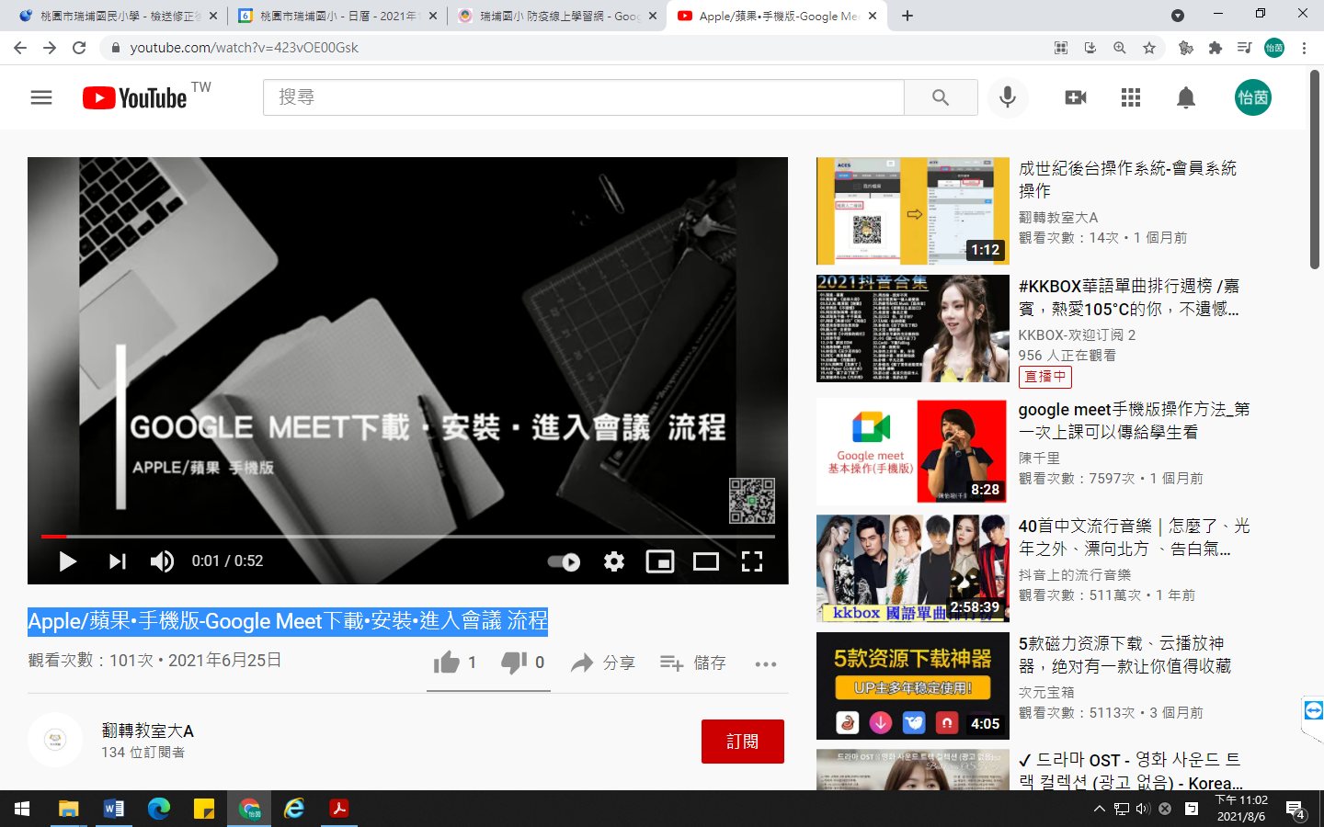](https://www.youtube.com/watch?v=423vOE00Gsk)

網址：<https://www.youtube.com/watch?v=423vOE00Gsk>

